Maxing Cards Name: ______________________________________________
Credit cards have very high interest rates, which means you need to pay a lot more if you don’t pay 100% of your bill each month. A common annual interest rate is 15%, which means you need to pay an extra 15% more than the actual cost each year.

Let’s say you’re trying to make ends meet, so you start paying your rent with your credit card. You pay the monthly minimum, but not the whole bill. By the end of the year, you owe $1,000. How fast will that add up?

- Write an equation to represent how much money you’ll owe over time.

- Complete the table below. Calculate how much you will owe each year for the first five years.

- Graph the relationship between what you owe and how many years have gone by.
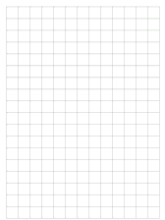

Year | Work | Total Debt
0 |  | $1,000
1
2
3
4
5

- Consider. If you couldn’t pay the $1,000 originally, how can you pay the $1,000 plus 15% interest now?

- $1,000 sounds like a lot. How much is the average credit card debt among American adults? (Look it up!)

- Do you plan on using a credit card? If so, how do you plan to pay it off? Do you think you’ll pay off the full amount each month? Or do you think you’ll just pay some at first, then the rest later plus the interest? Why?

