Hacking Quadratics Name: _______________________________________________

Today, you’ll hack quadratics. Using the ten examples below, explain what a quadratic is and how it works.

Standard form of a quadratic: $f\left(x\right)=ax^{2}+bx+c$

$$f\left(x\right)=6x^{2}+4x-3$$ | 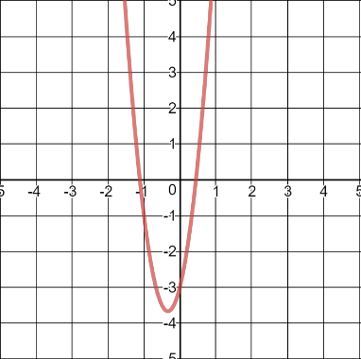 | $$f\left(x\right)=-0.42x^{2}-5.4x-7.2$$ | 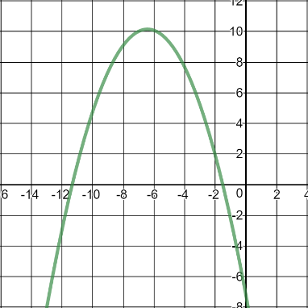
$$f\left(x\right)=-\frac{1}{5}x^{2}+3x+2$$ | 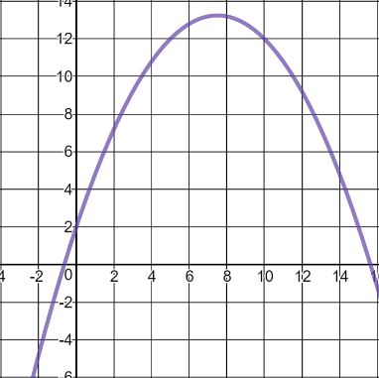 | $$f\left(x\right)=2x^{2}-8x+3$$ | 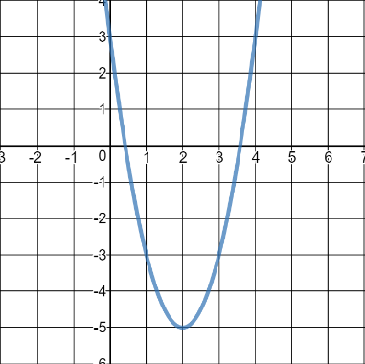
$$f\left(x\right)=x^{2}+2x$$ | 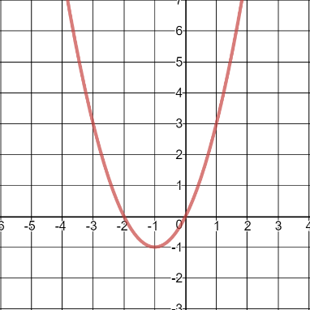 | $$f\left(x\right)=0.15x^{2}-4.4x+40$$ | 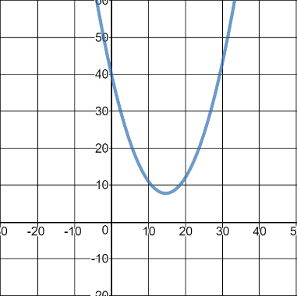
$$f\left(x\right)=-0.7x^{2}+2.5$$ | 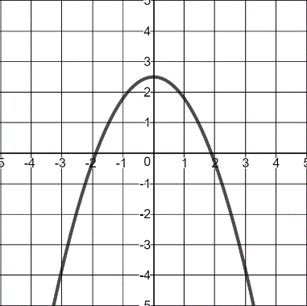 | $$f\left(x\right)=-2x^{2}-4x-2$$ | 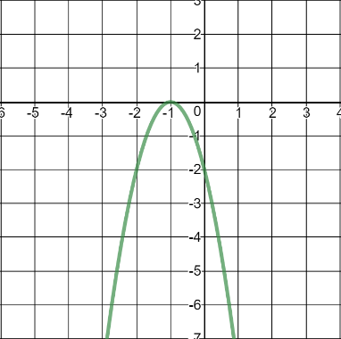
$$f\left(x\right)=\frac{3}{8}x^{2}+\frac{3}{2}x+5$$ | 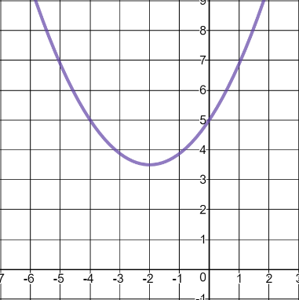 | $$f\left(x\right)=-4.9x^{2}+9.1x+4$$ | 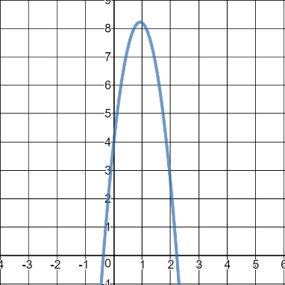
Teacher Guide

Put students into groups, then challenge them to create as many questions as they can for other groups. This will push students to identify patterns among the graphs and equations in a totally unrestricted way, letting them think in as many directions as possible. After collecting the initial round of questions from each group, present them to the class to see how many questions each group can answer. If you want to add any questions yourself, see a sample list below. (Note: Some questions may be unanswerable. Spirit points to the groups that recognize that and explain why.) If you want to be able to check in as a class, bucket the questions into checkpoints and review a new checkpoint every 10-20 minutes.

If you’re in the market for more structure, see an alternative below.

Checkpoint 1
- What makes a quadratic equation different from other equations?
- What does a quadratic look like?
- Why does it have that shape?

Checkpoint 2
- What makes some open down and others open up?
- What makes some narrow and others wide?
- How could you figure out which quadrant the vertex will be in?

Checkpoint 3
- Is it possible to turn a quadratic into a line?
- Is it possible for it to open just on the right side, but not the left?

Checkpoint 4
- What makes some quadratics start higher or lower?
- What makes some quadratics start more left or right?

Checkpoint 5
- What kinds of things might quadratics model? Spirit points for a variety of creative ideas! (I suggest saving this for Day 2, when you can make blank tables and have students hypothesize data for their ideas so they can then plot them and see whether they’re parabolic or not.)

Alternative: Use the sample checkpoints as a guide for jumpstarting or otherwise structuring the class. If you do, give the questions at the end—not the beginning—of each checkpoint. That way students won’t know what kinds of questions they need to answer, which will let them invent and answer as many possible questions on their own. If they don’t get an answer, then they can spend time during the next stage answering the questions posed. If you want to turn this into a competition, you might award two points for each question answered immediately and one for each answered eventually.

