Buying the Win Name: ________________________________________
Big colleges like having teams that win. To make it happen, they’re willing to pay a lot of money in coaches’ salaries and players’ scholarships. But exactly how much better does this make them?

Annual Income
The following data represents the 2013 winning percentage of college football teams relative to the head coach’s salary. This data only includes the biggest schools, which is why there are no teams with really low winning percentages.
College | Salary  (millions of dollars) | Win %
Alabama | 4.83 | 57
Boise State | 1.53 | 87
Central Florida | 1.39 | 50
Duke | 1.76 | 17
Michigan | 3.25 | 64
Oklahoma | 4.08 | 82
Texas | 5.19 | 82
Wisconsin | 2.60 | 68
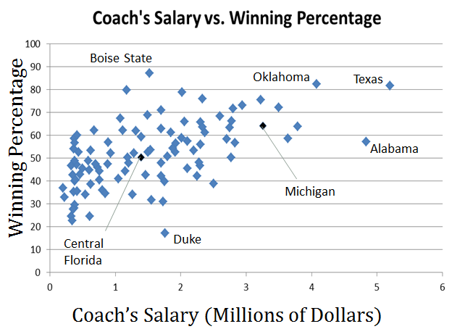

Imagine you’re the college athletics director at the University of Wisconsin. Your football team did pretty well, but you’re thinking about hiring a new coach. Before you make any decisions, you want to look at the data.

- First, the basics. What kind of correlation do you see between the coach’s salary and the team’s winning percentage? Why do you think it’s that kind of correlation? Does that mean you should pay a coach more or less if you want your team to do better?

- Now, the details. If we drew a line through the points for Central Florida and Michigan, we’d have a pretty good line of best fit. What is the slope of that line? Use the table for exact figures and round your answer to the nearest tenth.

- Among the big schools, it seems pretty clear that even teams with the lowest paid coaches typically a lot of their games. When coaches are paid well, they do even better.
- Using your answer from number two, what equation could you write for the line of best fit to represent this pattern?

- What does the slope of this equation tell us?

- What does the y-intercept of this equation tell us?

- Now that you have the equation, you can start to figure out what to pay your coach. Based on that equation, calculate what winning percentage you would expect your team to have if you paid the coach:
  - $1 million

  - $3 million

  - $6 million

  - $10 million

  - Do your answers for a through d make sense? Why or why not?

- Let’s say you know what winning percentage you want your team to have. How much would you have to pay your coach to expect a winning percentage of:
  - 75%

  - 80%

  - 100%

  - or even… 25%

  - Do your answers for a through d make sense? Why or why not?

- As the athletic director, you’d love to get a great deal—a coach that wins a lot, but doesn’t cost much money. Look back at the seven schools labeled on the scatter plot.
  - If they keep it up, which two coaches would give you the best value for your money? How do you know?

  - If they keep it up, which two coaches would give you the worst value for your money? How do you know?

Prep Work: Building Equations Name: ________________________________________

Review
Solve each equation
1. $7\left(1-4x\right)=175$ 2. $6x-30=-3(-8-5x)$

Practice
Use the information given to write an equation of the line.
3. Slope: $7$ 4. Slope: $2$
Contains: $(1, 4)$ Contains: $(-2, -1)$

5. Contains: $(2, -1)$ 6. Contains: $(-2, 5)$
Contains: $(1, -4)$ Contains: $(0, -3)$

7. Contains: $(-3, 0)$ 8. Contains: $(0, 2)$
Contains: $(-1, -5)$ Contains: $(2, 5)$

