Foreign Aid: Argentina
As a group, your goal is to figure out how to distribute $3 billion in grant money to the countries on the scatter plot.

As a representative of Argentina, your priority is to get as much money as you can for your country. If you’re feeling generous, you can also try to be fair to other countries.

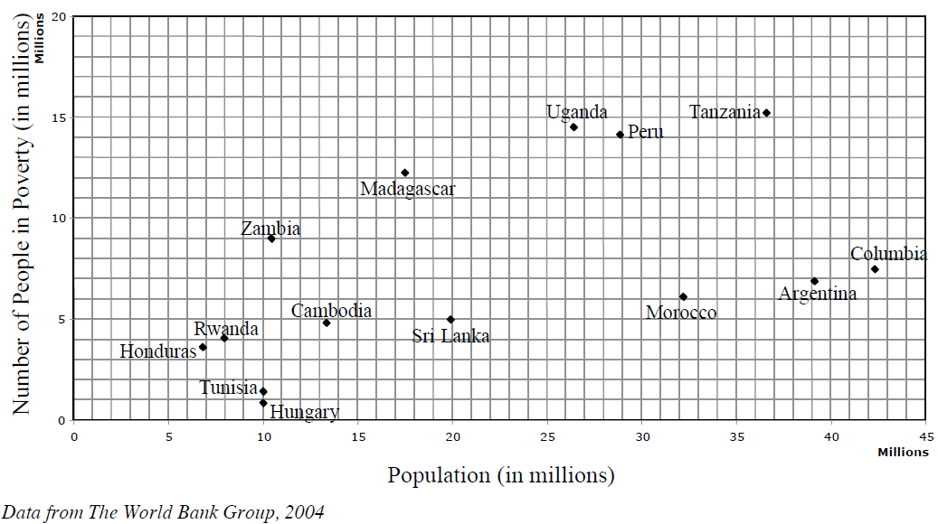
Roles
Each of you will have a separate role. Choose wisely and write your names here!

Recorder: Calculator:
Who writes the answers Who crunches the numbers

Diplomat: Liaison:
Who represents you in the debate Who asks the questions

Pre-Debate
- What’s your country’s biggest goal for these negotiations?

- What kind of information might be important for the negotiations?
  - How big is your country?
  - How many people are in poverty?
  - What percent of your population is in poverty?
  - Are you bigger or smaller than most other countries?
  - Do you have a higher or lower percentage of people in poverty than most other countries?
  - What might you be able to do with the money?

  - What else do you want to know?

- If you were to draw a line through the graph and say everyone on one side gets a grant and everyone on the other side doesn’t, how would you draw the line? Why? (Describe the line by saying which points it would go through.)

Foreign Aid: Madagascar
As a group, your goal is to figure out how to distribute $3 billion in grant money to the countries on the scatter plot.

As a representative of Madagascar, your priority is to get as much money as you can for your country. If you’re feeling generous, you can also try to be fair to other countries.

Roles
Each of you will have a separate role. Choose wisely and write your names here!

Recorder: Calculator:
Who writes the answers Who crunches the numbers

Diplomat: Liaison:
Who represents you in the debate Who asks the questions

Pre-Debate
- What’s your country’s biggest goal for these negotiations?

- What kind of information might be important for the negotiations?
  - How big is your country?
  - How many people are in poverty?
  - What percent of your population is in poverty?
  - Are you bigger or smaller than most other countries?
  - Do you have a higher or lower percentage of people in poverty than most other countries?
  - What might you be able to do with the money?

  - What else do you want to know?

- If you were to draw a line through the graph and say everyone on one side gets a grant and everyone on the other side doesn’t, how would you draw the line? Why? (Describe the line by saying which points it would go through.)

Foreign Aid: Honduras
As a group, your goal is to figure out how to distribute $3 billion in grant money to the countries on the scatter plot.

As a representative of Honduras, your priority is to get as much money as you can for your country. If you’re feeling generous, you can also try to be fair to other countries.

Roles
Each of you will have a separate role. Choose wisely and write your names here!

Recorder: Calculator:
Who writes the answers Who crunches the numbers

Diplomat: Liaison:
Who represents you in the debate Who asks the questions

Pre-Debate
- What’s your country’s biggest goal for these negotiations?

- What kind of information might be important for the negotiations?
  - How big is your country?
  - How many people are in poverty?
  - What percent of your population is in poverty?
  - Are you bigger or smaller than most other countries?
  - Do you have a higher or lower percentage of people in poverty than most other countries?
  - What might you be able to do with the money?

  - What else do you want to know?

- If you were to draw a line through the graph and say everyone on one side gets a grant and everyone on the other side doesn’t, how would you draw the line? Why? (Describe the line by saying which points it would go through.)

Foreign Aid: Tanzania
As a group, your goal is to figure out how to distribute $3 billion in grant money to the countries on the scatter plot.

As a representative of Tanzania, your priority is to get as much money as you can for your country. If you’re feeling generous, you can also try to be fair to other countries.

Roles
Each of you will have a separate role. Choose wisely and write your names here!

Recorder: Calculator:
Who writes the answers Who crunches the numbers

Diplomat: Liaison:
Who represents you in the debate Who asks the questions

Pre-Debate
- What’s your country’s biggest goal for these negotiations?

- What kind of information might be important for the negotiations?
  - How big is your country?
  - How many people are in poverty?
  - What percent of your population is in poverty?
  - Are you bigger or smaller than most other countries?
  - Do you have a higher or lower percentage of people in poverty than most other countries?
  - What might you be able to do with the money?

  - What else do you want to know?

- If you were to draw a line through the graph and say everyone on one side gets a grant and everyone on the other side doesn’t, how would you draw the line? Why? (Describe the line by saying which points it would go through.)
Foreign Aid: Morocco
As a group, your goal is to figure out how to distribute $3 billion in grant money to the countries on the scatter plot.

As a representative of Morocco, your priority is to get as much money as you can for your country. If you’re feeling generous, you can also try to be fair to other countries.

Roles
Each of you will have a separate role. Choose wisely and write your names here!

Recorder: Calculator:
Who writes the answers Who crunches the numbers

Diplomat: Liaison:
Who represents you in the debate Who asks the questions

Pre-Debate
- What’s your country’s biggest goal for these negotiations?

- What kind of information might be important for the negotiations?
  - How big is your country?
  - How many people are in poverty?
  - What percent of your population is in poverty?
  - Are you bigger or smaller than most other countries?
  - Do you have a higher or lower percentage of people in poverty than most other countries?
  - What might you be able to do with the money?

  - What else do you want to know?

- If you were to draw a line through the graph and say everyone on one side gets a grant and everyone on the other side doesn’t, how would you draw the line? Why? (Describe the line by saying which points it would go through.)

Foreign Aid: Tunisia
As a group, your goal is to figure out how to distribute $3 billion in grant money to the countries on the scatter plot.

As a representative of Tunisia, your priority is to get as much money as you can for your country. If you’re feeling generous, you can also try to be fair to other countries.

Roles
Each of you will have a separate role. Choose wisely and write your names here!

Recorder: Calculator:
Who writes the answers Who crunches the numbers

Diplomat: Liaison:
Who represents you in the debate Who asks the questions

Pre-Debate
- What’s your country’s biggest goal for these negotiations?

- What kind of information might be important for the negotiations?
  - How big is your country?
  - How many people are in poverty?
  - What percent of your population is in poverty?
  - Are you bigger or smaller than most other countries?
  - Do you have a higher or lower percentage of people in poverty than most other countries?
  - What might you be able to do with the money?

  - What else do you want to know?

- If you were to draw a line through the graph and say everyone on one side gets a grant and everyone on the other side doesn’t, how would you draw the line? Why? (Describe the line by saying which points it would go through.)

Foreign Aid: Team USA
As a group, your goal is to figure out how to distribute $3 billion in grant money to the countries on the scatter plot.

As a representative of the United States, you aren’t going to get any money. You’re the biggest donor to the United Nations. Your priority is to determine how to use the money to help the people that need it the most.

Roles
Each of you will have a separate role. Choose wisely and write your names here!

Recorder: Calculator:
Who writes the answers Who crunches the numbers

Diplomat: Liaison:
Who represents you in the debate Who asks the questions

Pre-Debate
- What’s your country’s biggest goal for these negotiations?

- What kind of information might be important for the negotiations?
  - How many countries are eligible for aid?
  - How much money would each country get if you split the $3 billion evenly among all of them?
  - How much money would each country get if you split the $3 billion evenly among half of them?
  - If you add up the populations, about how many total people are in those countries?
  - If you gave the money directly to each person, instead of each country, how much money would each person get if you divided the $3 billion evenly among all of them?

  - What else do you want to know?

- If you were to draw a line through the graph and say everyone on one side gets a grant and everyone on the other side doesn’t, how would you draw the line? Why? (Describe the line by saying which points it would go through.)

Foreign Aid: Team Germany
As a group, your goal is to figure out how to distribute $3 billion in grant money to the countries on the scatter plot.

As a representative of the Germany, you aren’t going to get any money. You’re one of the biggest donors to the United Nations. Your priority is to determine how to use the money to help the people that need it the most.

Roles
Each of you will have a separate role. Choose wisely and write your names here!

Recorder: Calculator:
Who writes the answers Who crunches the numbers

Diplomat: Liaison:
Who represents you in the debate Who asks the questions

Pre-Debate
- What’s your country’s biggest goal for these negotiations?

- What kind of information might be important for the negotiations?
  - How many countries are eligible for aid?
  - How much money would each country get if you split the $3 billion evenly among all of them?
  - How much money would each country get if you split the $3 billion evenly among half of them?
  - If you add up the populations, about how many total people are in those countries?
  - If you gave the money directly to each person, instead of each country, how much money would each person get if you divided the $3 billion evenly among all of them?

  - What else do you want to know?

- If you were to draw a line through the graph and say everyone on one side gets a grant and everyone on the other side doesn’t, how would you draw the line? Why? (Describe the line by saying which points it would go through.)

Post-Debate
- What equation did the class decide on?

- How will the money be divided up among the countries that get it—evenly or per capita?

- How much money did your country get? (For USA and Germany, determine which country will receive the most and how much it will receive.)

- Do you think this is fair? Why?

- Look back at Question 4. Rewrite the equation as an inequality. (Replace the equal sign with an inequality sign.)

- If you were a country with a population of 25 million people, how many of those people would need to be in poverty for you to be eligible for a grant? (Be sure to keep your inequality sign!)

- If you were a country with 10 million people in poverty, what would your population need to be to be eligible for a grant?

- Imagine you’re an enormous country like India, with over 1.25 billion people.
  - How many people would need to be in poverty to be eligible for a grant?

  - If India were added to the graph and it were eligible for a grant, how much money would it get?

  - How much money does that end up being per person?

